Assignment 4: Becoming an Independent Data Scientist

1. Region and Domain:

Region : Turkey

Domain : Soccer, Superleague Championships

2. How have the win percentages for the (Fenerbahce, Galatasaray and Besiktas) change over the last sixty years?

3. Links:

<https://tr.wikipedia.org/wiki/S%C3%BCper_Lig_%C5%9Fampiyonlar%C4%B1_listesi>

<https://www.kaggle.com/vkutelc/turkey-super-league-championship-in-history/version/1>

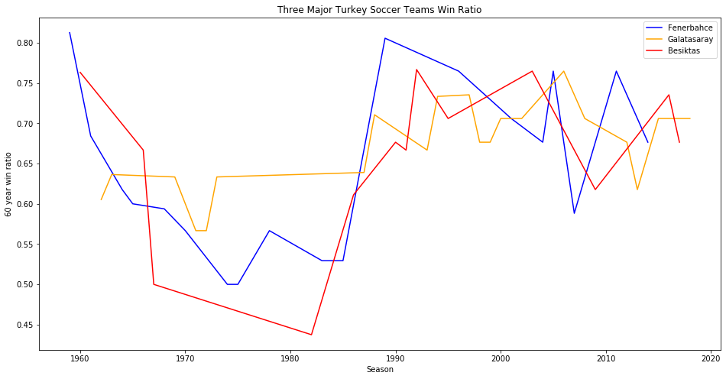4. Image:

5. Discussion:

This visualization was concerned with answering the question of how the win percentages of the three major Turkish soccer teams (Fenerbahçe, Galatasaray and Besiktas) have changed over the last 60 years. Data concerning wins and losses by season for each team are downloaded from Kaggle.com. Any tie games are also included as played games in the analysis in order to provide a more level comparison between the sports. A 10 year moving average was plotted to help the reader identify any major trends in the team’s win percentages. The plot indicates years of high win percentage for Fenerbahce around 1990 and 2000, with periods of decline following both high points. Galatasaray’ win percentage shows a stabil and never below 0.5%. Besiktas shows a sharp increase in early 1990’s and 2000 to 2005. Both Fenerbahce and Besiktas begins good in 1960’s, but both of them show a decrease in win ratio until 1985. After 1985 all teams win ratios are seemed to be improved and looks like each other.